Sovereign Practice PPG
Princes Park Health Centre
Wartling Road, Eastbourne, BN22 7PG
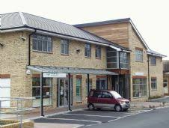

WINTER NEWSLETTER
Let’s Get Together...
TUESDAY 17 DECEMBER 2019
08.30 – 12 & 13.30 – 16.30
** FREE REFRESHMENTS **
MEET UP FOR A CHAT AND A CUPPA
SPEAK TO HEALTH PROFESSIONALS INFORMALLY
NO APPOINTMENTS NEEDED
☆ Watch our Waiting Area noticeboard for details ☆
COME AND JOIN US!
PRINCES PARK HEALTH CENTRE, WARTLING ROAD, EASTBOURNE

Out of Hours
Between 6.00pm and 8.30am Monday to Friday and weekends
your calls will be managed by our out-of-hours provider.
Please telephone 01323 744644 and you will be automatically redirected.
The nearest NHS Walk-in Centre is at Eastbourne railway station.
It is open seven days a week from 8.00am to 8.00pm. Tel: 01323 726650.
------------------------------------------------------------------------------------------
Zero Tolerance
The practice supports the Government's NHS Zero Tolerance Campaign.
We ask patients to treat GPs and practice staff courteously,
without violence or abuse.
The health centre is protected by CCTV cameras.

Patient Participation Group
The 'National Association for Patient Participation'
has a dedicated and useful website for all those wishing
to learn more about PPG's, you can visit this site at www.napp.org.uk
If you wish to contact the PPG group then please use their dedicated email address:
sovereign-practice.ppg@nhs.net
Date of next meeting: These are held on the second Tuesday of each month
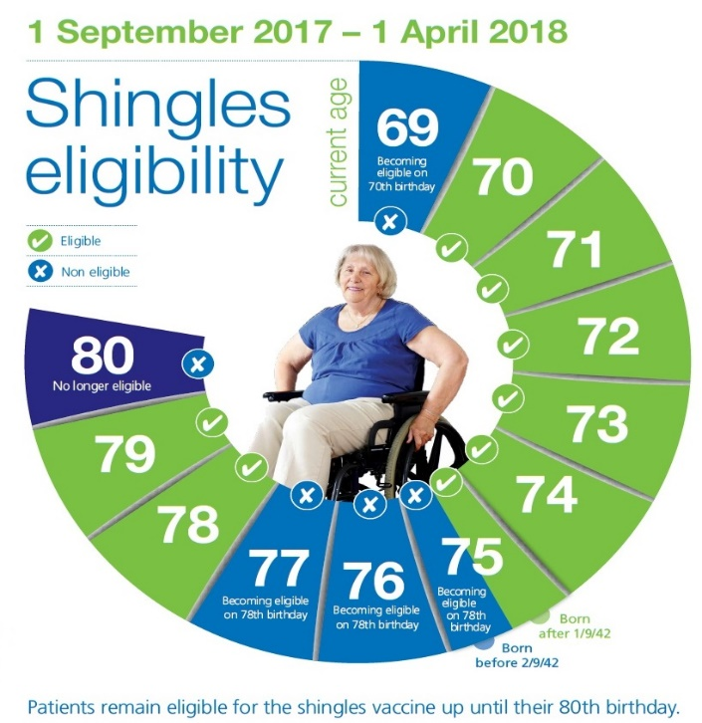

Child Health
All the doctors in the practice are approved to do child health screening. We strongly recommend that all children be immunised as and when due. You will normally receive an appointment from child health through the post when your baby's immunisation is due. The baby will also be assessed by the doctor at six weeks of age as part of the postnatal check-up. The health visitor will also monitor the child's development and will be happy to advise on any problems regarding child care.

East Sussex Mental Health Directory of Community Support
What if I'm in crisis and need help now?
Mental health services
Carer support services
Drug and alcohol services
Armed forces services
Non-mental health services
Physical health and wellbeing
Lifestyle changes
Overview of mental health support in East Sussex
Test Results
To receive the results of blood tests,
urine tests etc.,
please telephone your usual surgery between 10.00am and 4.30pm on 744644.

