
Princes Park Health Centre
Newsletter
www.princesparkhealthcentre.co.uk

Volume 4 Issue 2 March 2016

An Easter message from
Dr Jonathan Andrews,
Partners and Staff.



We would like to take this
opportunity to wish you and
your families a very happy
Easter.



Surgery Closure

The surgery will be closed on Friday 25th, Monday 28th March for the Easter Bank Holidays

The surgery will also be closed from 12.30pm on Wednesday 20th April for staff training.

Voice from the Patient Participation Group

The purpose of this group is to gain views from the patients on how well the current surgery services are run and then feedback these comments constructively to the practice.

The current Chairperson would like to hear views and suggestions from other patients on how best the PPG can operate. You can make contact by writing to the PPG direct, ‘Care Of’ the surgery, or use the PPG suggestion box under the noticeboard.

“Why not visit the dedicated noticeboard for the PPG in the reception area.”

If you are interested in joining the group please contact Graham Hunt at the surgery, or ask at reception for further details.

Date of the next meeting is; Thursday 28th April at 12.30pm.

At the last meeting held on March 17th it was decided that it would be a good idea to run a baby and toddler clothes bank to run alongside the food bank. Please look out for this new collection box and help out some of our families that need this support.


Did you know?

30% of appointments are now pre-bookable up to two weeks in advance.

Did you know?

That Dr Andrews and Dr Rabuszko offer evening appointments that are also pre-bookable on a Tuesday and Thursday between 6.30 – 7.40pm.

“Boots”, the chemist next door, also stays open until 7.30pm on these evenings.

Dr Southward offer’s early morning appointments that are also pre –bookable on a Wednesday morning between 7.00-8.10am.

Did you Know?

Last month in November there were 207 missed appointments!!! This is way too HIGH!!!
and wasted over 34 hours of SURGERY time!!!! So please, if you cannot attend your clinic appointment then make a cancellation. This then allows others waiting, to utilise the freed up place. Remember appointments can also be cancelled online if you are registered.

Wear it.Beat it day for the British Heart Foundation

On Friday - 5th February 2016 it was Wear it.Beat it day for the British Heart Foundation, so something red was worn by all the staff to help beat heart disease. There was a collection made in the surgery on the day and a total of £151.83 was raised, a big thanks for all your support......

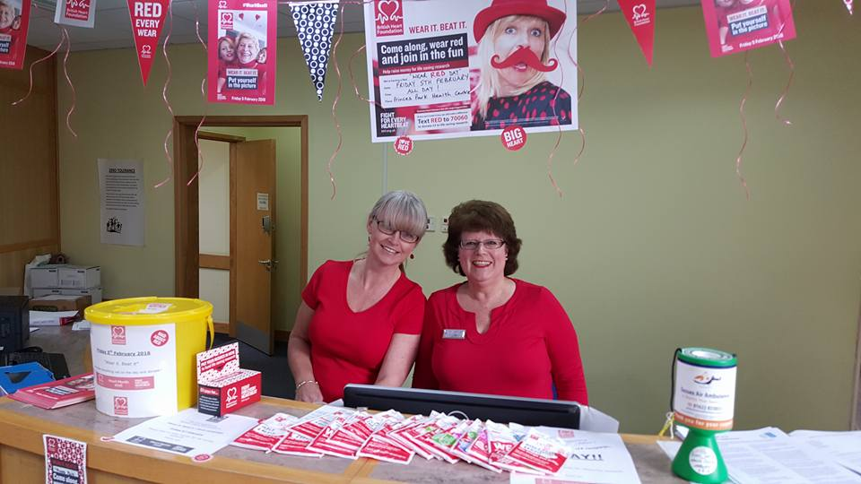

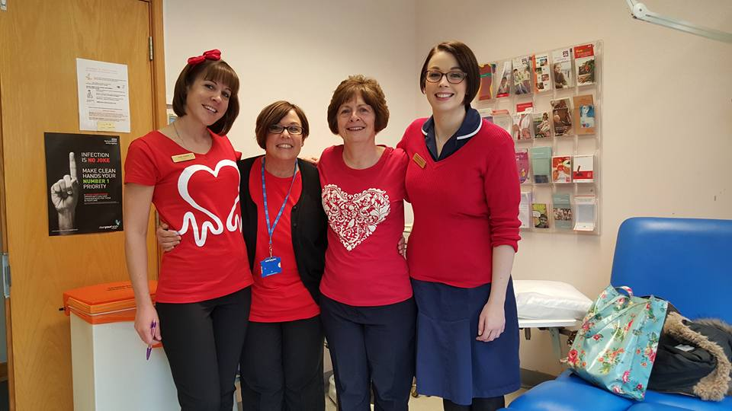

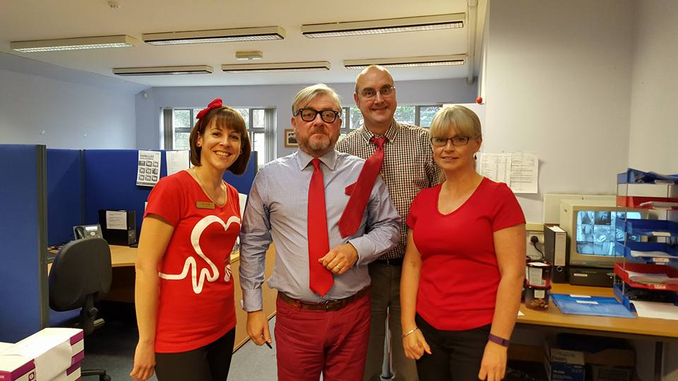

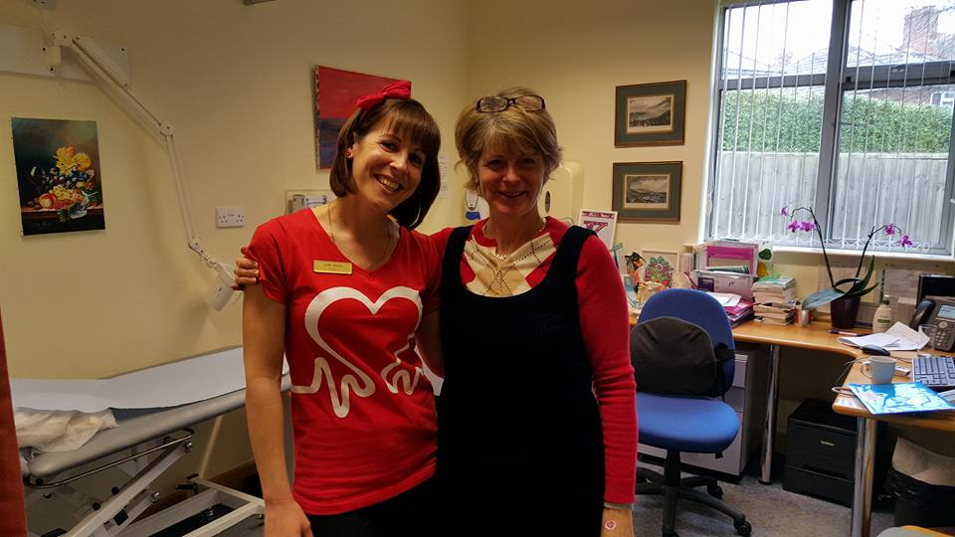



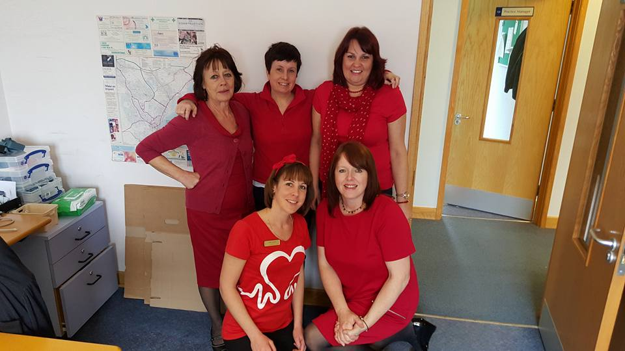

Did you Know?

CQC – stands for
Care Quality Commission.

Our latest inspection report was published on 4th December 2013 and shows us to be meeting all CQC national standards.

For a copy of the full report go to our website, or ask at reception to see a printed version.

Old Glasses



Please note that you can leave old/unwanted glasses at reception or in the box under the Taxi Freephone. These are collected and given out to charities.
A note from the Eastbourne Lions Club about this charity work;

“Eastbourne Lions Club has provided a bin for your used spectacles. These are sent on to be sorted, recycled and graded in preparation for use in eye camps in Africa and India. Eastbourne Lions collect and send around 12,000 pairs a year.”

Zero Tolerance

This practice supports the Government’s NHS Zero Tolerance Campaign. We ask patients to treat GPs, PNs and all practice staff courteously, without a hint of either physical or verbal violence/abuse. Any patient found guilty of such actions will be removed from the surgery list straight away.
Princes Park is a very busy practice and at times the wait to see your GP or PN may be longer than is expected. All the staff are under increasing pressure, with patient expectations at a high, but they are doing their best and just ask for a little patience at times.




Car Parking at Princes Park Health Centre

If there are no car parking spaces left please do not block the car park area by sitting in your car double parked. This causes problems for the delivery lorries/vans that then have problems with access.
Please park on the road instead and remember the DISABLED BAYS are only for those with a blue badge, many thanks.

Hot off the press, at long last there will be more Disabled Parking on the road outside the Health Centre, the council have put up the warning plates on the grass verge and the road marking will follow shortly.

The NHS Friends and Family Test

On 1st December 2014 the NHS Friends and Family Test went live across 8ooo GP practices in England. The aim is to drive service improvement in local healthcare by providing patients with the opportunity to give feedback on their experience. For the month of, February, 94.2% of our patients said that they would recommend our surgery to friends and family if they needed similar care or treatment. Thank you for your support.



Eastbourne Food bank

Princes Park supports the Eastbourne Food Bank through the generosity of you the patient. The scheme is on-going throughout the year. Please continue with your donations whenever you can.

Summary of January 2016 governing body meeting
The governing bodies of Eastbourne, Hailsham and Seaford CCG and Hastings and Rother CCG met jointly in public on 27 January 2016 at The Kings Centre, Eastbourne. If you were unable to join us at this meeting you will find a summary of the main reports below. All papers for this meeting are available in our meetings section.
Questions from the public
Questions were asked about the recent Sussex-wide reprocurement of patient transport services, and East Sussex Better Together (ESBT). Answers to all questions will be provided in full in the minutes of this meeting.
Opening remarks from the chairs
Dr Martin Writer, chair of Eastbourne, Hailsham and Seaford CCG, welcomed Keith Grimes as the new governing body GP representing the Seaford locality. Dr Grimes practises at the walk-in centre in Eastbourne. Dr Writer was looking forward to working David Clayton-Smith following his appointment as chair of East Sussex Healthcare NHS Trust, and had been involved in stakeholder events as part of the selection of the new chief executive at the trust and looked forward to the announcement of an appointment in due course.
He had had a positive and constructive meeting with Eastbourne MP Caroline Ansell, who had a keen grasp of and interest in local health and social care.
Roger Elias, chair of Hastings and Rother CCG, reflected on his attendance at the recent Healthcare Financial Management Association conference, and had been proud to update the conference on our local achievements under East Sussex Better Together.
Chief Officer’s report
Chief Officer Amanda Philpott advised the governing body on the contents of the recent NHS planning guidance, which supports local health and social are systems to achieve the aims of the NHS Five Year Forward View. As well as requiring CCGs to develop long-term sustainability and transformation plans, the guidance issues nine “must-dos” for 2016/17, which focus on meeting national standard and access targets. A lay member, lead GP and senior management team member had been assigned to oversee their delivery.
CCGs were proposing the ESBT footprint (Eastbourne, Hailsham and Seaford CCG and Hastings and Rother CCG, together with East Sussex County Council) as the footprint for placed-based planning, with Kent Surrey and Sussex constituting a wider clinical network.
Dr David Warden was appointed to succeed Dr Roger Elias as CCG chair from April 2016, following a unanimous vote in favour. Dr Elias had previously announced his retirement as chair.
Patient Story
In a new feature for governing body meetings, Chief Nurse Allison Cannon outlined a patient story that highlighted issues with the diagnosis and treatment of sepsis. Patient stories will be presented at the start of every governing body meeting, as part of our measures to help ensure the CCG remains patient-focussed in its decision-making, and to identify any learning we can apply to improve services as commissioners ,
Patient and public involvement
Lay members Barbara Beaton and Frances Hasler reported on key progress in the CCGs’ engagement activity. This included the ongoing success of the East Sussex Better Together public reference forum, plans for a range of locality-based public events from April 2016 and the development of communications and engagement plans to support the key ESBT workstreams.
Communications and Engagement Delivery Plan
The governing bodies noted the progress in implementing our plans to ensure effective communications and engagement. It was noted how the CCGs had launched a Health Help Now app, enabling people to access real time information about local healthcare services from mobile devices. The CCGs had refreshed and tested their communications and engagement toolkit and this was being rolled out to staff through training workshops.
Annual report of the Director of Public Health 2015-16
Members noted and discussed the contents of this year’s annual report, which focusses on how we can support health and wellbeing in East Sussex by developing services and partnerships in local communtities.
East Sussex Better Together
Governing bodies discussed the progress made by week 77 of the 150 week programme to transform local health and care services in East Sussex. This included:
- The continued rollout of Health and Social Care Connect
- Implementation of Integrated Locality teams by April 2016
- Progress on the whole-system redesign of urgent care
- Launch of Health Help Now App
In response to the latest NHS Planning Guidance, members agreed to submit a geographical footprint of Eastbourne, Hailsham and Seaford CCG, Hastings and Rother CCG and East Sussex County Council for the development of required STPs. East Sussex County Council and the Health and Wellbeing board had had formally endorsed this same footprint the day before. The governing body also approved an expression of interest to develop a fast-tracked Sustainability and Transformation Plan, and to pursue an opportunity to trial the reinvention of a new acute medical model in small district general hospitals.
Addressing health inequalities - Health Hastings and Rother programme
Members received an update on the significant progress made by the healthy Hastings and Rother programme, which is delivering a range of initiatives to address health inequality. The programme is forecast to spend its £5m budget in 2015/16. Programme manager Richard Watson outlined a number of key projects including the awarding of a series of community grants, new services to support awareness and detection of cancer and the development of community health and wellbeing centres
CQC Inspections
Chief Nurse Allison Cannon presented a report providing assurance of the actions the CCG was taking to support improvements to local services in response to CQC findings in respect of East Sussex Healthcare NHS Trust, Sussex Partnership Foundation Trust, Brighton and Sussex University Hospitals NHS Trust and local GP practices.
Integrated quality and performance report
Governing bodies discussed key indicators of quality and performance for all providers of services.
There remained concerns that East Sussex Healthcare NHS Trust (ESHT) continued to fall below the cancer target threshold for both 2 week wait referrals and 62 day urgent referral to first treatment. ESHT has produced a Cancer Improvement Plan to address this and the CCG has served the trust with a contract performance notice.
The trust had not met the target for stroke patients admitted directly within 4hrs in month 8, so further assurance was being sought around how this is being addressed.
The 18-week referral to treatment target was currently being met.
Both CCGs were forecast to meet financial targets.
Reporting from the chairs of CCG committees
The chairs of the Eastbourne, Hailsham and Seaford CCG Primary Care Commissioning Committee, the Quality and Governance Committees, the Performance and Delivery Committees and the Audit Committee provided verbal updates and highlighted key points from recent meetings.

Assurance Framework and Risk Management Strategy
The governing body ratified the CCGs’ Risk Management Strategy for 2016, which sets out how we identify corporate risks and mitigating actions in order to achieve our objectives.
Information Governance Policies and Procedures
Members noted updates to the CCGs’ Information Governance Policies, which were submitted for ratification by the Quality and Governance Committee on 20 January.
Research capability funding
The governing body approved the release of £25,000 research Capability Funding from the Health Research Authority for research projects at two local practices – £12,500 to Sea Road Surgery, Bexhill, and £12,500 to Little Common Surgery, Bexhill.
Next meeting
The next joint meeting in public of the CCGs will take place on:
- 23 March 2016, Manor Barn, 4 De La Warr Road, Bexhill, TN40 2JA, at 2.30pm.
Relevant papers will be published in our meetings section.


A note to our Readers

If anybody would like to contribute an article and be included in the next newsletter, then please leave your comments at reception or email; grahamhunt@nhs.net

Princes Park Website

Finally you can find a copy of this newsletter on our website plus lots of other useful information. www.princesparkhealthcentre.co.uk

Finally an Urgent Request
Your Patient Participation Group (PPG) Needs You



Please ask at the Reception Desk for Details or contact grahamhunt@nhs.net

Eastbourne
Healthy Walks
Hampden Park, Tuesdays, 10.30am meet outside the Lakeside Tea Chalet, Hampden Park Drive
Shinewater, Fridays, 10.30am meet outside the Co-op, Milfoil Drive
Hailsham, Thursday’s, 10.30am, meet at the War Memorial
Free, friendly walks.
Every week, just an hour
Please wear suitable shoes and dress for the weather conditions on the day
Contact: Paula Hubens, Healthy Walks Project Officer
07740 899559/ p.hubens@tcv.org.uk



About Healthwatch East Sussex

East Sussex Community Voice (CIC) is commissioned by East Sussex County Council to deliver Healthwatch East Sussex, which is your independent local consumer champion for health and care services.
This means that we:
- Gather views and understanding the experiences of patients and the public
- Make peoples’ views known
- Promote and support the involvement of people in the commissioning and provision of local care services and how they are scrutinized
- Recommend investigation or special review of services via Healthwatch England or directly to the Care Quality Commission (CQC)
- Provide advice and information about services and support for making informed choices; and
- Make the views and experiences of people known to Healthwatch England and providing a steer to help it carry out its role as national champion.

In summary Healthwatch East Sussex will act as the Consumer Voice for health and social care in East Sussex.

For more information call us on 0333 101 4007, text 07826 021 114 (we can call back) or email enquiries@healthwatcheastsussex.co.uk

