
Princes Park Health Centre
Newsletter
www.princesparkhealthcentre.co.uk

Volume 4 Issue 1 January 2016

A New Year message from
Dr Jonathan Andrews,
Partners and Staff.



We would like to take this
opportunity to wish you and
your families a very happy
and prosperous New Year.



Voice from the Patient Participation Group

The purpose of this group is to gain views from the patients on how well the current surgery services are run and then feedback these comments constructively to the practice.

The current Chairperson would like to hear views and suggestions from other patients on how best the PPG can operate. You can make contact by writing to the PPG direct, ‘Care Of’ the surgery, or use the PPG suggestion box under the noticeboard.

“Why not visit the dedicated noticeboard for the PPG in the reception area.”

If you are interested in joining the group please contact Graham Hunt at the surgery, or ask at reception for further details.

Date of the next meeting is; Thursday 14th January at 1.00pm.

Dry January
Alcohol Concern’s Dry January is their annual campaign where they challenge people to give up alcohol for the 31 days of January.
Find out more, get involved and sign up at Dry January. Download your free guide to this year’s campaign along with fundraising ideas and posters by visiting www.dryjanuary.org.uk . They are also on Facebook at www.facebook.com/DryJanuary or on Twitter @DryJanuary.

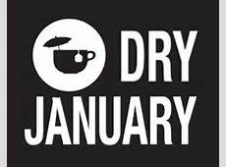

Outpatient waiting times now online

ESHT have added their average waiting times to their website, in order for all to understand their current position. The link is here: http://www.esht.nhs.uk/our-services/outpatients/average-wait/ It will also be included in all patient correspondence sent by ESHT.

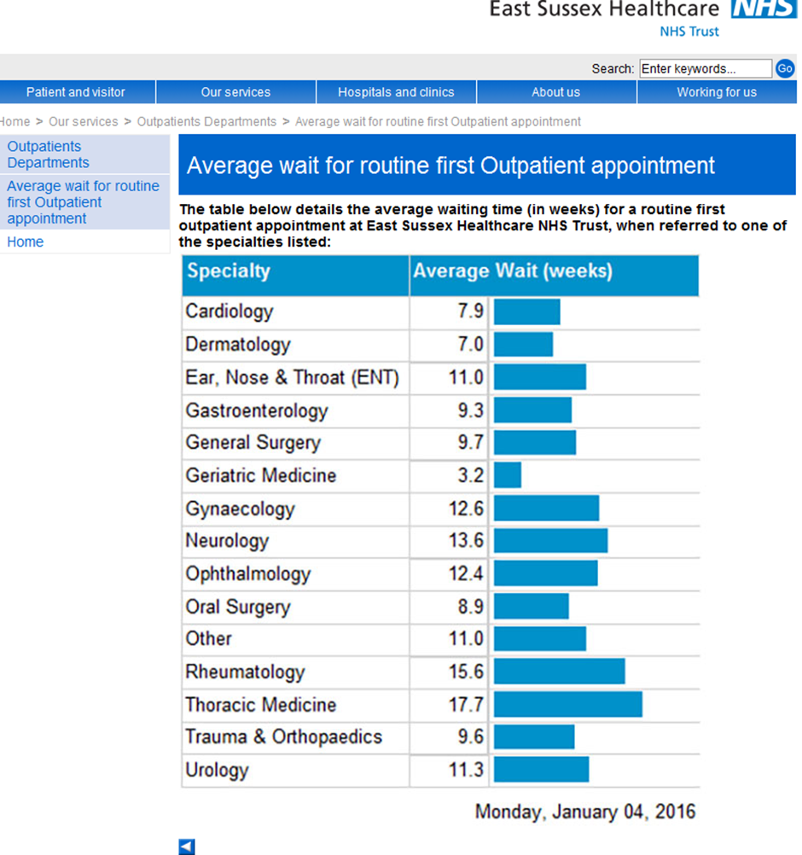

Did you know?

30% of appointments are now pre-bookable up to two weeks in advance.

Did you know?

That Dr Andrews and Dr Rabuszko offer evening appointments that are also pre-bookable on a Tuesday and Thursday between 6.30 – 7.40pm.

“Boots”, the chemist next door, also stays open until 7.30pm on these evenings.

Dr Southward offers early morning appointments that are also pre –bookable on a Wednesday morning between 7.00-8.10am.

Did you Know?

Last month in December there were 209 missed appointments!!! This is way too HIGH!!!
and wasted over 34 hours of SURGERY time!!!! So please, if you cannot attend your clinic appointment then make a cancellation. This then allows others waiting, to utilise the freed up place. Remember appointments can also be cancelled online if you are registered.



NHS HEALTH CHECKS

An NHS Health Check helps to identify potential risks early and by having this check and following the advice of your health professional you improve your chances of living a healthier life.

This check is part of a new national scheme to help prevent the onset of heart disease, strokes, type 2 diabetes and kidney disease.

Everyone between the ages of 40 and 74 who has not been diagnosed with the conditions mentioned is entitled to a free health check every five years. The check is to assess your risk of developing any of the above conditions and they take about 20 to 30 minutes where you will be asked some simple questions about your family history and any medication you are taking, a blood test to check cholesterol levels and your blood pressure.

If you are outside the age range and are concerned about your health, you should contact your GP.

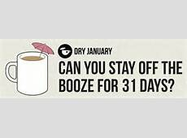

Did you Know?

CQC – stands for
Care Quality Commission.

Our latest inspection report was published on 4th December 2013 and shows us to be meeting all CQC national standards.

For a copy of the full report go to our website, or ask at reception to see a printed version.

Old Glasses



Please note that you can leave old/unwanted glasses at reception or in the box under the Taxi Freephone. These are collected and given out to charities.
A note from the Eastbourne Lions Club about this charity work;

“Eastbourne Lions Club has provided a bin for your used spectacles. These are sent on to be sorted, recycled and graded in preparation for use in eye camps in Africa and India. Eastbourne Lions collect and send around 12,000 pairs a year.”

Zero Tolerance

This practice supports the Government’s NHS Zero Tolerance Campaign. We ask patients to treat GPs, PNs and all practice staff courteously, without a hint of either physical or verbal violence/abuse. Any patient found guilty of such actions will be removed from the surgery list straight away.
Princes Park is a very busy practice and at times the wait to see your GP or PN may be longer than is expected. All the staff are under increasing pressure, with patient expectations at a high, but they are doing their best and just ask for a little patience at times.


Shingles Vaccination Information
From September 1 2015 the shingles vaccine is routinely available to people aged 70 and 78.
In addition, anyone who was eligible for immunisation in the first two years of the programme but has not yet been vaccinated against shingles remains eligible until their 80th birthday. This includes:
- people aged 71 and 72 on 1 September 2015
- people aged 79
You can have the shingles vaccination at any time of year, though many people will find it convenient to have it at the same time as their annual flu vaccination. If your birthday falls within the following date ranges then you are currently eligible for the vaccine and can book an appointment;
02/09/1935 – 01/09/1936 = 79 years old
02/09/1936 – 01/09/1937 = 78 years old
02/09/1944 – 01/09/1945 = 70 years old
02/09/1943 – 01/09/1944 = 71 years old
02/09/1942 – 01/09/1943 = 72 years old
Car Parking at Princes Park Health Centre

If there are no car parking spaces left please do not block the car park area by sitting in your car double parked. This causes problems for the delivery lorries/vans that then have problems with access.
Please park on the road instead and remember the DISABLED BAYS are only for those with a blue badge, many thanks.



The NHS Friends and Family Test

On 1st December 2014 the NHS Friends and Family Test went live across 8ooo GP practices in England. The aim is to drive service improvement in local healthcare by providing patients with the opportunity to give feedback on their experience. For the month of, December, 92.5% of our patients said that they would recommend our surgery to friends and family if they needed similar care or treatment. Thank you for your support.

Eastbourne Food bank

Princes Park supports the Eastbourne Food Bank through the generosity of you the patient. The scheme is on-going throughout the year. Please continue with your donations whenever you can.



New website and app to help people know where to go for treatment

Eastbourne, Hailsham and Seaford CCG have launched an innovative new website and mobile phone app to help people in East Sussex to understand where they should go for treatment, especially when they are not sure what to do or who to contact.
The Health Help Now web app can be found online at www.healthhelpnow-nhs.net and is free to everyone who lives and works in East Sussex. It functions like a mobile phone app and helps people check their symptoms and find the best place for treatment – showing which services near them are open. It will help people to know when to go to A&E, and when not to.
It breaks down symptoms by age –baby, child, teenager, adult and older adult. This is to make it easier for people to find the right treatment for them.
Health Help Now has been developed with input from local GPs, hospital doctors, paramedics and other health professionals. It is thought to be the most detailed and sophisticated local NHS web app in the country.
After clicking on age, symptoms and location, people are presented with a list of suggestions for treatment. The most suitable choice for most people is listed first and the other suggestions follow in order. It shows the nearest services and is time sensitive so details whether services are open or closed and provides a map of their location.
Health Help Now also offers advice – such as where to buy children’s medication when pharmacies are closed - and links to other useful websites.
The ground-breaking, easy-to-use web app works on smartphones, tablets, laptops and desktop computers.
Dr Martin Writer, chair of Eastbourne, Hailsham and Seaford CCG, said: “Health Help Now means our local community will be able to find the most appropriate help fast when they need it.
“We hope people will find this easy-to-use web app helps them to determine when to go to A&E and when to go elsewhere. Around 40 per cent of people who attend A&E leave without any treatment. We hope that by using this web app, patients will become more aware of other services better able to meet their needs. This may save them a long wait in A&E and should help to take the pressure off A&E, especially over the busy winter period.”
The web app is available via the website www.healthhelpnow-nhs.net and can be saved to your phone, tablet or computer for easy use. Anyone who doesn’t have internet access is advised to dial NHS 111 for urgent healthcare advice 24 hours a day.

How to add Health Help Now to your mobile device or tablet
The mobile web app can be used just like a native (download) mobile app on your device. Below are instructions to add icons using the three most popular mobile platforms.
iOS
Open Safari and go to www.healthhelpnow-nhs.net. Click on the share icon and select the "Add to Home Screen" icon. An icon will then be placed on your home screen.
Windows Phone 7/8
Open Internet Explorer and go to www.healthhelpnow-nhs.net Click on the "..." options icon and select "pin to start", the web page will appear on the start menu although windows will not use the standard icon but a screen shot for the icon instead.
Android
Open Chrome and go to www.healthhelpnow-nhs.net Click on the add bookmark icon and click save. Open up the bookmarks tap and hold the icon and select "add to home screen". The icon will now be added to your tablet or phones home screen.
Android devices are available in various different hardware and software combinations. Whilst every effort has been made to cater for as many Android devices as possible some older versions of the Android OS may experience problems when using the application. If you are experiencing problems it is recommended that you first upgrade your device to the latest release of the Android operating system.

How to add Health Help Now to your computer
Google Chrome
To create a bookmark, click on the white star icon in the location bar. The star will turn yellow and a bookmark for the page will be created in the bookmarks toolbar.
Mozilla Firefox
To create a bookmark, click on the star icon in the Location bar. The star will turn yellow-blue and a bookmark for the page you're on will be created in the Unsorted Bookmarks folder.
Internet Explorer
If you are on a site that you want to make a favourite, click the Favourites button, and then click Add to favourites. You can rename the favourite and choose a folder to save it in, and then click Add.
For sites that you want quicker access to, save it to your Favourites bar by clicking the Add to Favourites bar button. If the Favourites bar isn't visible, right-click the Favourites button, and then click Favourites bar.
Opera
Save a webpage as a bookmark by clicking the star in the address field and choosing "Add to bookmarks".
Safari
Open www.healthhelpnow-nhs.net. Click on “Bookmarks” on the toolbar at the very top, then click “Add Bookmark”, the second option on the list. Click “Add”.

A note to our Readers

If anybody would like to contribute an article and be included in the next newsletter, then please leave your comments at reception or email; grahamhunt@nhs.net

Princes Park Website

Finally you can find a copy of this newsletter on our website plus lots of other useful information. www.princesparkhealthcentre.co.uk

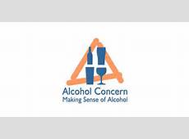
Medical Corner
Following on from Dry January which raises the awareness of too much alcohol consumption, we look at one person’s thoughts from last year;
Are you taking part in Dry January?
The 31-day challenge, spearheaded by charity Alcohol Concern, encourages people to banish the booze for the whole of January.
Participants can also raise money for Alcohol Concern, who help people harmed through alcohol misuse, by collecting sponsorship.
Last year I took part in Dry January and raised money for the charity — it was a challenge, but a rewarding one.
If you're giving up alcohol this month, I hope it goes well — here are some tips that might help you reach the end of the month without reaching for a bottle of wine.
Buddy up. Having someone in the same booze-free boat can be a great source of encouragement. My boyfriend and I took part in Dry January together last year, and supported each other in swapping pints of beer for pints of squash.
Try new things. With nights out and evenings in the pub less likely (unless you're happy joining your mates but sticking to soft drinks), use Dry January to try new activities of a weekend. Kick-start your 2016 fitness campaign with a brisk walk, try new recipes for tasty Saturday night dinners, plan your 2016 bucket list or finally get round to clearing out the loft. With no Sunday morning hangovers to deal with, you may find your weekends get more productive.
Count the pennies. Giving up drinking post-Christmas may well result in a healthier January bank balance. Fewer pub rounds, the option of driving home instead of paying for a taxi — why not put the money saved to one side and treat yourself with your savings at the end of the month?
Save cash with Dry January
Don't be afraid to say no. As I learned last year, a wild night out when you're not drinking and everyone else is can be pretty rubbish. In their giddy/tipsy states, a loud bar or club might be just their cup of tea, while you just want to stay in with a cuppa. Don't force yourself out if you'd rather curl up with a box set and some leftover Christmas chocolates.
Think of the benefits. According to Alcohol Concern, quitting drinking for 31 days will result in better sleep, more energy, clearer skin, weight loss, no hangovers, a sense of a achievement and a healthier relationship with alcohol. Win.
...but don't expect miracles. Adverts for Dry January might give the impression that you'll end the month revitalised, energised, 10lbs lighter and ready for a triathlon. But while it no doubt does your liver good and boosts your general health, you may find you don't feel all that different come February 1. But that's fine, you've still achieved something!
Explore the alcohol-free aisle . It's not all Becks Blue you know — there are more alcohol-free beers out there than you might think. If you miss the taste of a nice ale, check out the alcohol-free section in supermarkets and off-licences and try a few booze-free brews. My favourite was Brewdog's Nanny State.
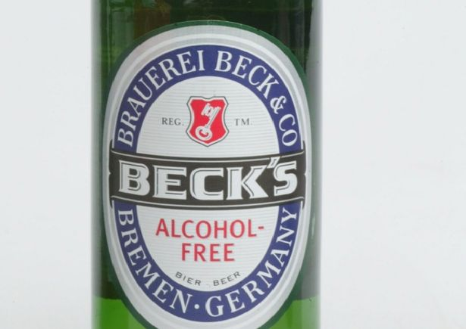Becks alcohol-free beer

Learn healthy habits. Dry January can help you gain some perspective on your usual drinking habits — and once you've quit for a month, cutting down permanently can be easier. Dry January can help you assess your relationship with alcohol and implement healthier future habits.
Do it for a good cause. Why not raise money for Alcohol Concern while taking on Dry January? Getting people to sponsor you can help motivate you, and you get the fuzzy feeling at the end of the month that you've helped others as well as yourself.
Tea is your friend. If you miss your Friday night bottle of beer or glass of wine, stick the kettle on. A nice hot cuppa to wrap your hands around is just as soothing and stress-busting, if you ask me —Yorkshire Tea got me through Dry January. Seriously.
If you're taking on Dry January, good luck!
Finally an Urgent Request
Your Patient Participation Group (PPG) Needs You


Please ask at the Reception Desk for Details or contact grahamhunt@nhs.net

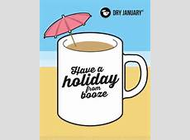



Eastbourne
Healthy Walks
Hampden Park, Tuesdays, 10.30am meet outside the Lakeside Tea Chalet, Hampden Park Drive
Shinewater, Fridays, 10.30am meet outside the Co-op, Milfoil Drive
Hailsham, Thursday’s, 10.30am, meet at the War Memorial
Free, friendly walks.
Every week, just an hour
Please wear suitable shoes and dress for the weather conditions on the day
Contact: Paula Hubens, Healthy Walks Project Officer
07740 899559/ p.hubens@tcv.org.uk

About Healthwatch East Sussex
East Sussex Community Voice (CIC) is commissioned by East Sussex County Council to deliver Healthwatch East Sussex, which is your independent local consumer champion for health and care services.
This means that we:
- Gather views and understanding the experiences of patients and the public
- Make peoples’ views known
- Promote and support the involvement of people in the commissioning and provision of local care services and how they are scrutinized
- Recommend investigation or special review of services via Healthwatch England or directly to the Care Quality Commission (CQC)
- Provide advice and information about services and support for making informed choices; and
- Make the views and experiences of people known to Healthwatch England and providing a steer to help it carry out its role as national champion.

In summary Healthwatch East Sussex will act as the Consumer Voice for health and social care in East Sussex.

For more information call us on 0333 101 4007, text 07826 021 114 (we can call back) or email enquiries@healthwatcheastsussex.co.uk

